A Guaranteed Compression Scheme for Repetitive DNA Sequences
Rivals, J. P. Delahaye, M. Dauchet, and O. Delgrange
Data Compression Conference, pp. 453-464, 1996
Abstract
- Introduction
- Overall presentation of Cfact
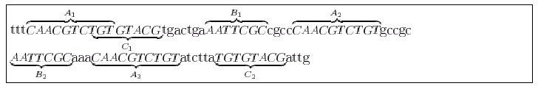
A₁, B₁, C₁ are the respective reference occurrences for factors A, B, and C.
A₂, B₂, A₃, C₂ are selected by parsing to be replaced by specific binary codes, which include a reference to the corresponding reference occurrence.
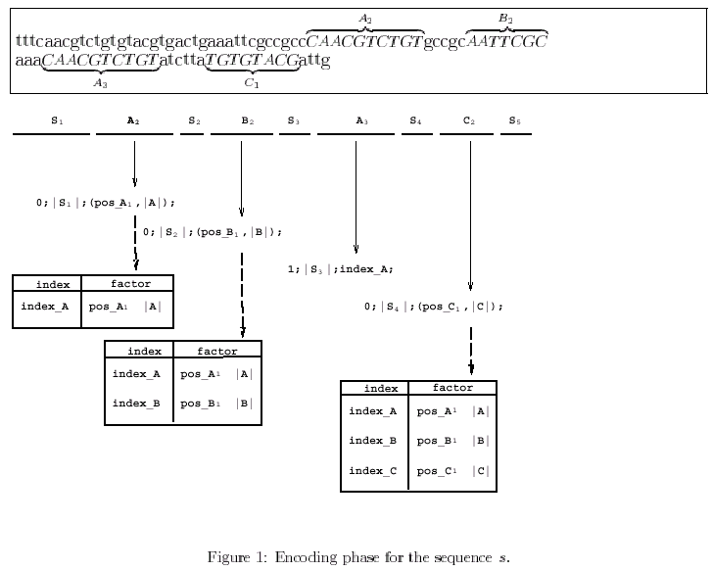
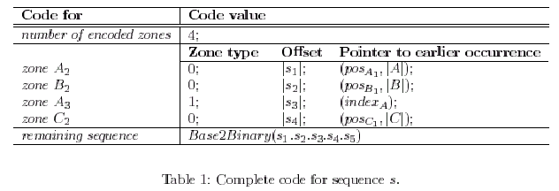
s = s₁.A₂.s₂.B₂.s₃.A₃.s₄.C₂.s₅
- Encoding scheme
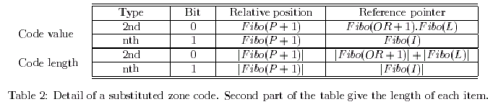
P is its relative position
OR is the reference occurrence absolute position
L is the length of the repeated factor
I is the dictionary index of the factor
- Parsing strategy
- It is a maximal repeat, i.e. if it belongs to the repeats list
- It does not overlap an already encode zone
- Its potential gain is positive
Data structure for LEZ (List of Encoded Zones).
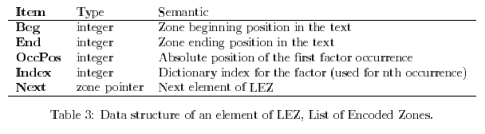
- Complexity, advantages and guarantee
The time complexity of Cfact is in O(n²) and its space complexity is in O(nlogn)
- Conclusion
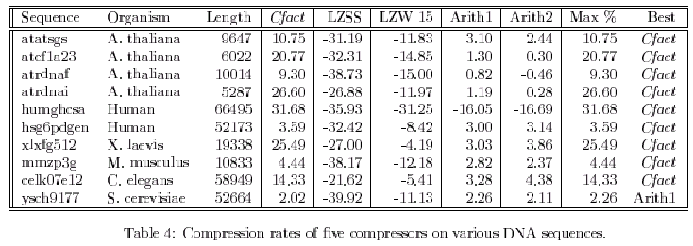
Created by: Ming-Cheng Lin
Date: Dec.19, 2000

